**[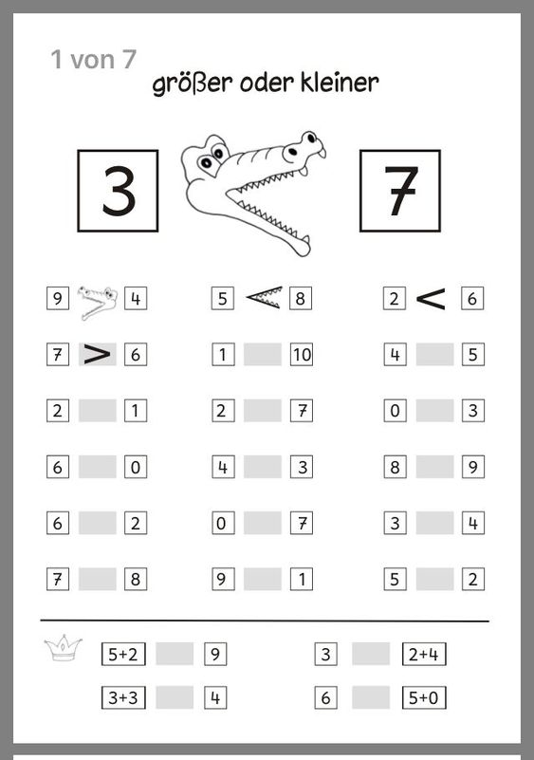](https://fitnesshealthy.pinturest.site/fitness/mathematik/)**